1. **Functional Requirements**

**Ride.Request: Requesting a ride.**

**.Register:** The system shall confirm user registration for the car booking service.

**.No:** If the Passenger is not registered for booking a car, the system shall give the Passenger options to register now and book a ride, or to exit.

**.Location :** The system shall prompt the user to input their current location or enable GPS for automatic location detection.

**.No :** If there is no access to passenger location , the system shall ask user to share location manually, or he/she cannot book a ride.

**.Destination:** The system shall allow the user to specify their destination for the car ride.

**Ride.Fare: Offer fare for ride.**

**.Offer:** The system shall allow the passenger and driver to offer fares to each other.

**.Accept :** The system shall allow both the passengers and driver to agree on the same fare.

**.No :** If passenger or driver does not agree on the same fare then they must be shown different rides.

**Ride.Cancel : Cancel a ride.**

**.Initiation:** The system shall allow the user to initiate the cancelation process.

**.Confirmation:** The system shall prompt the user to confirm the cancellation to avoid accidental cancellations.

**.Reason:** The system shall allow the user to give valid reason to cancel the ride.

**Ride.Confirm: Confirm the ride.**

**.Initiate:** The system shall allow the passenger to initiate a ride confirmation after a successful booking.

**.Confirmation Details**: The system shall display relevant details for confirmation, including the driver's information, car details, and estimated time of arrival.

**Ride.Pay : Pay for ride.**

**.Method:** The system shall allow the passenger to select payment method for ride (for e.g easypaisa, jazzcash or cash).

**.OK** : If the payment is successful then the app must display a message of payment confirmation.

**Ride.Feedback : Give ride feedback.**

**.Rating :** The system shall implement a rating system (e.g., stars) for users to express their satisfaction level, with clear guidelines on the meaning of each rating.

**.Description :** The system shall allow user to give feedback of ride in their own words.

1. **Data Requirements**

**Logical Data Model**

* 1. **Data Dictionary**

|  |  |  |  |  |
| --- | --- | --- | --- | --- |
| Data Element | Description | Composition or Data Type | Length | Values |
| User ID | Unique identifier for each user | Alphanumeric | 6 |  |
| User Name | User's full name | Alphabetic |  |  |
| Email Address | User's email address | Alphanumeric |  |  |
| Phone Number | User's phone number | AAAA-BBBBBBB.  A for network info and B for Number. | 11 |  |
| Password | User's password for secure login | Alphanumeric | 8 | Special Signs permitted |
| Pick-up Location | User's current location or manually entered address | Alphanumeric |  | hyphens and  commas permitted |
| Destination Location | User's desired destination address or landmark | Alphanumeric |  | hyphens and  commas permitted |
| Car Type | Selected car type (e.g., sedan, SUV, luxury) | Alphabets |  |  |
| Estimated Fare | Approximate fare for the selected ride | Integer |  | Initial values is 1 |
| Payment Method | Selected payment method (e.g., credit card, saved wallet, cash) | payment amount  + payment method  + transaction number |  |  |
| Driver ID | Unique identifier for the assigned driver | Alphanumeric | 6 |  |
| Driver Name | Driver's full name | Alphabets |  |  |
| Driver Rating | Driver's average rating from previous rides | Integers | 5 | Initial value is 0. |
| Car Model | Assigned car model and license plate | Integers |  |  |
| Pick-up ETA | Estimated arrival time of the driver | time, HH:MM |  |  |
| Drop-off ETA | Estimated drop-off time at the destination | time, HH:MM |  |  |
| Actual Distance | Total distance traveled during the ride | Integers | 10 |  |
| Actual Time | Total ride duration in minutes | time, HH:MM |  |  |
| Final Fare | Calculated fare based on actual distance and time | Integer |  |  |
| Ride Feedback | User's feedback on the driver and ride experience | Alphanumeric | 200 | Words and integers both are allowed |
| Ride Rating | User's rating for the driver and ride experience | Integer | 5 |  |
| Ride Receipt | Detailed receipt for the ride, including fare breakdown and payment method | payment amount  + payment method  + transaction number |  |  |

**4.3 Reports**

**User Profile Report**

|  |  |
| --- | --- |
| **Report ID** | **CAR-RPT-1** |
| **Report Title** | User Profile |
| **Report Purpose** | Comprehensive user details and ride history. |
| **Priority** | Medium |
| **Report Users** | Users of the car booking app |
| **Data Sources** | User account database, Ride history database |
| **Frequency** | On-demand, static data |
| **Disposition** | Displayed on the app screen, printable if permitted |
| **Latency** | Within 3 seconds |
| **Visual Layout** | Portrait mode |
| **Header** | Report title, user's name, date and time |
| **Footer** | Page number (if printed) |
| **Body Fields** | See detailed list below |
| **Selection Criteria** | User ID or user's full name |
| **Sort Criteria** | Reverse chronological order based on ride history |
| **End-of-Report Indicator** | None |
| **Interactivity** | Drill down for detailed ride information |
| **Security Restrictions** | Restricted to authenticated users, access to own profile only |

**4.4 Data integrity, Retention and Disposal**

**DI-1:** Retain individual user ride history for 12 months following ride completion, ensuring availability for reference and analysis.

**DI-2:** Implement secure disposal mechanisms for ride history data beyond the 12-month retention period, minimizing unauthorized access.

**5. External Interface Requirements**

**5.1 User Interfaces**

* **UI-1:** The In-Drive Car Booking App shall feature an intuitive and user-friendly interface, adhering to the industry-standard mobile application design guidelines.
* **UI-2:** Each screen within the app shall include a help icon or link that provides context-sensitive guidance to users on how to navigate and use specific features.
* **UI-3:** The app's user interface shall support seamless interaction through touch gestures, and it should be designed to ensure easy navigation and booking using touch controls alone. It should also be compatible with keyboard input for users with specific accessibility needs.

**5.2 Software Interfaces**

* **SI-1:** *Location Services*
  + **SI-1.1:** The app shall utilize the device's GPS capabilities to determine the user's current location for accurate booking and navigation.
  + **SI-1.2:** The app shall interact with mapping services (e.g., Google Maps) to provide real-time information on vehicle availability and estimated arrival times.
* **SI-2:** *Payment Gateway*
  + **SI-2.1:** The app shall integrate with a secure and reliable payment gateway to facilitate transactions for booking services.
  + **SI-2.2:** The payment gateway interface shall support various payment methods, including credit/debit cards and digital wallets.

**5.3 Hardware Interfaces**

No specific hardware interfaces have been identified for the In-Drive Car Booking App at this time.

**5.4 Communications Interfaces**

* **CI-1:** The app shall send push notifications to the user's device to confirm the successful booking of a car, including details such as car type, estimated arrival time, and driver information.
* **CI-2:** In the event of any issues with the booking process, the app shall notify the user through push notifications, providing clear information on the problem and potential solutions.
* **CI-3:** The app shall have an integrated messaging system allowing communication between the user and the assigned driver, fostering a seamless experience during the journey.

**6. Quality Attributes**

**6.1 Usability**

USE1- The indrive app shall allow passengers to request a ride with a single interaction

USE2- 90% of new passengers shall be able to successfully order a ride without errors on their first try

**6.2 Performance Requirements**

PRE1- The user shall be able to login within 1 minute.

PRE2- The system shall display confirmation message between 5 to 8 seconds once the fare is accepted by the passenger and driver.

PRE3- The system shall show correct location of driver and passenger up to 5 meter.

**6.3 Security Requirements**

SEC1- Passenger shall login to system every time before requesting a ride

SEC2- Driver shall be able to view the live location of passenger only if the passenger allows.

**6.4 Safety Requirement**

SAF1- The location of passenger will automatically be hidden as soon as the ride is completed

SAF2- The system shall ensure 100% that drivers without driving license do not register them self.

SAF3- The system shall ensure 95% that passengers without CNIC do not register them self.

**6.5 Availability Requirement**

AVL1- The system shall be available 99% of the time.

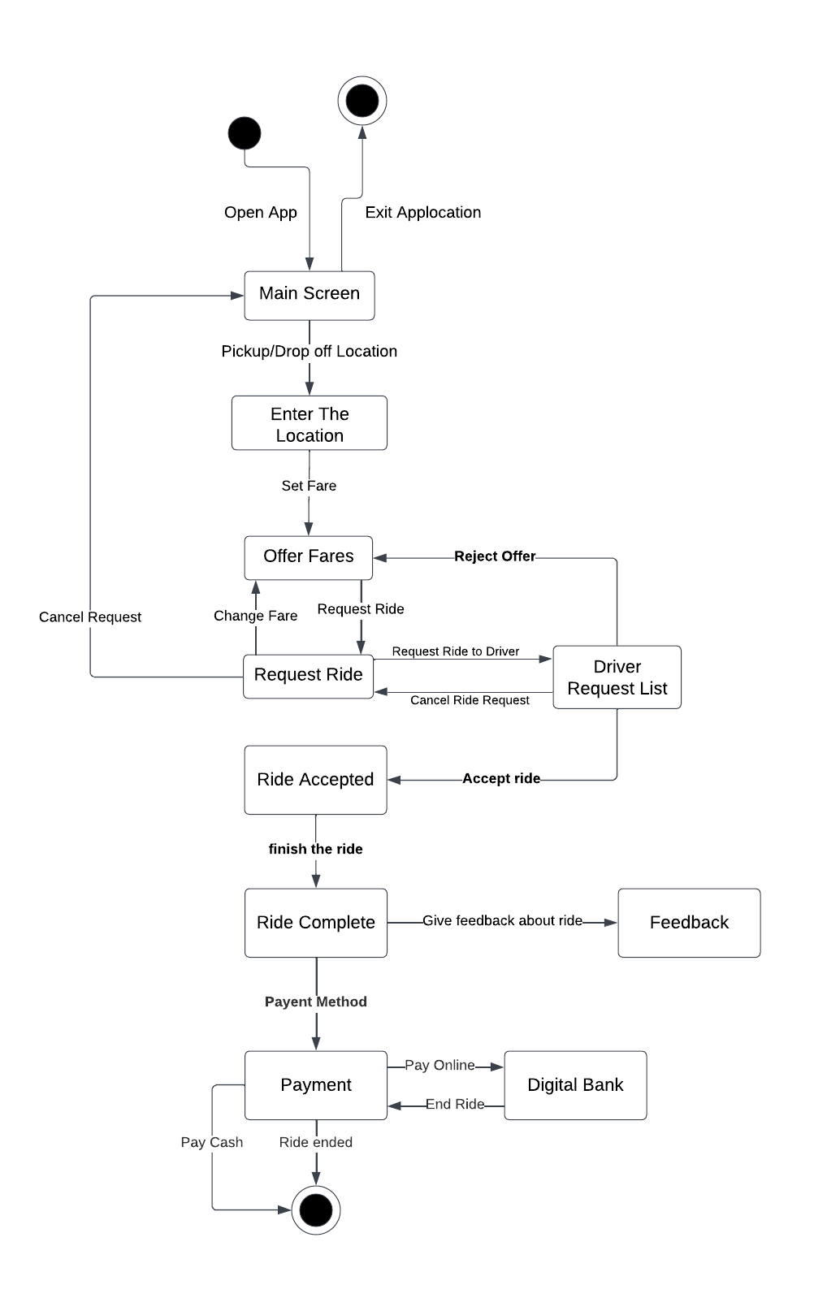

**DIALOG MAP**

**Data Flow Diagram**

Verify transection

verified

Ride details

Transection request

Negotiate fares

Driver location

Customer location

Transection status

Give review to Customer

Driver location

Customer location

Set fares

Give review to driver

Request ride

Digital Banks

Transection

Account

Customer

Driver

Feedback

Feedback

Fares

Offer fares

GPS

Location

Payment details

Ride info

Payment

Option

Place Ride

**Data Model**

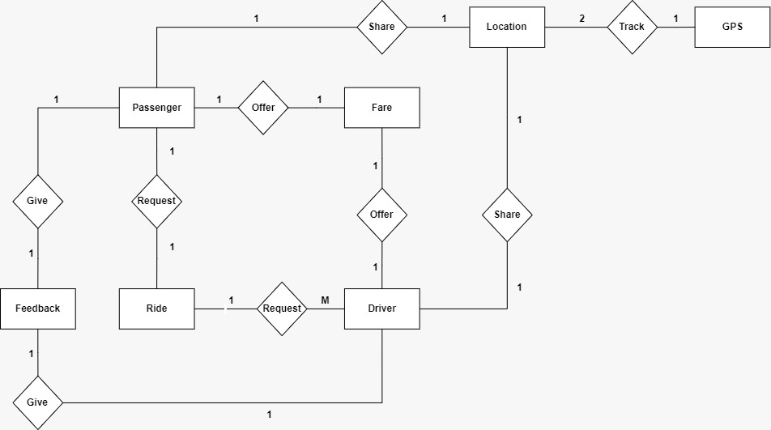

**Test Cases**

**Test Case#1**

**Given** that user is not registered in indrive app,

**When** the user requests a ride,

**Then** the user shall be given the options to register now or exit.

**Test Case#2**

**Given** that the user and driver offer fare,

**When** user and driver accept fare

**Then** the ride will be accepted.

**Test Case#3**

**Given** that the user initiates the cancelation process,

**When** the user confirms the cancelation of ride

**Then** ride will be canceled.

**Test Case#4**

**Given** that the ride is completed,

**When** the system asks the user to select a payment method,

**Then** the user shall be able to select a payment method of his choice.

**Test Case#5**

**Given** that the ride is completed,

**When** the system asks the user to give ratings  
  **Then** the user shall be able to give ratings.

**Test Case#6**

**Given** that the ride is completed,  
**When** the system asks the user to give ratings,

**Then** the user shall have the option to skip the rating process